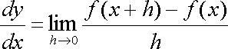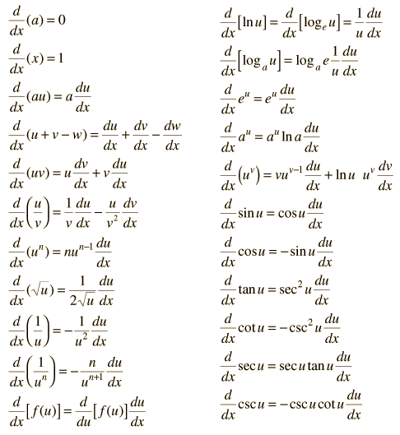  
  
  
If f’(x) > 0 on an interval, then f is increasing on that interval.  
  
If f’(x) < 0 on an interval, then f is decreasing on that interval.

If f’’(x) > 0 on an interval, then f is concave up on that interval.

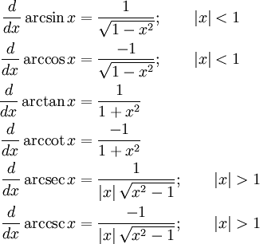If f’’(x) < 0 on an interval, then f is concave down on that interval. $$m=\lim_{x→a}{\frac{f\left(x\right)-f(a)}{x-a}}$$ 
Inflection point: point on curve where concavity changes.

Suppose that *c* is a critical number of a continuous function *f* defined on an interval.

1. If f’(x) > 0 for all x < c and f’(x) < 0 for all x > c, then f(c) is the absolute maximum value of f.
2. If f’(x) < 0 for all x < c and f’(x) > 0 for all x > c. then f(c) is the absolute minimum value of f.

Suppose that *c* is a critical number of a continuous function *f.*

1. If f’ changes from positive to negative at *c,* then *f* has a local maximum at *c.*
2. If f’ changes from negative to positive at *c,* then *f* has a local minimum at *c.*
3. If f’ does not change sign at *c* (for example, if f’ is positive on both sides of *c* or negative on both sides), then *f* has no local maximum or minimum at *c.*